TEAM PAYAMAN

ONLINE MERCH

EUNICE ESCONDE

JOHN MARCO JOVES

VERNA LEONOR

DANICA PLAZO

BSCS 3-A

**INTRODUCTION**

A lot of people around the world prefer to shop online and purchase products from brands and companies that they cannot find or not available in their area. These days, and with the assistance of the new innovation and the help of the internet, anywhere around the world people began to buy things online by just scrolling, searching and sitting in their homes. Buying things through online is a simple task to do. It is currently having a significant part in everyone's life particularly elderly people, as well as people busy with their work and do not have much time to stop by at the mall. On this trying time, many people are getting their needs through online shopping. It provides an entirely convenient service for its customers, by being able to save the item in the cart, and buy it later on. Because of the countless advantages and benefits of online shopping, masses of entrepreneur and aspiring businessperson are entering a world of online shopping.

Team Payaman is one of the top tier online sellers in the Philippines. The said team are originally created with famous vloggers on YouTube and eventually one of the members sell t-shirts and cap. Because of this, other members also started selling merch like beauty products, clothing, condiments, and stickers. The Team Payaman Merch Website tends to be more convenient to the team to promote and sell their products and aims to merge all the products in one ecommerce website.

**SCOPE AND DELIMITATION**

The researchers aim to develop a convenient and a *‘one-stop shop’* ordering website for Team Payaman Merch since they are using different social media to sell their products. The website focuses on the basic elements. The coverage of the study is to easily purchase of products of Team Payaman.

The intention of the study is to help and assist the customer to easily choose item what they want to order with less time and effort. The website includes different web pages. The first web pages enclose the HOME PAGE of the website that consist of trendy and most popular products. It also contains the social media accounts of the clothing line that may use to communicate for more detailed data about and how the services are set. The PRODUCT PAGE of the website that contains all the merch of the team, sorted according to the catalog. It is packed with basic contents such as product image, price, short details and an add to cart button. The ACCOUNT PAGE can be easily access and done by filling up the form with their personal information, such as username, email and password. The ABOUT PAGE comprises the brief information of the team and short quotation of the famous vlogger Lincoln Velasquez.

**DATA DICTIONARY**

|  |  |  |  |  |  |
| --- | --- | --- | --- | --- | --- |
|  | NAME | Quantity of Item | TYPE OF ITEM | DESCRIPTION | EXAMPLE |
| Seller | Seller ID | ∞ | Clothes | Identification of the Seller | 1234567890 |
| Seller Name | ∞ | Clothes | Name of the Seller | Juan Dela Cruz |
| Seller Email | ∞ | Clothes | Email address of the Seller | seller@00.com |
| CUSTOMER | Customer ID | 20 | Clothes | Identification of the Customer | 1234567890 |
| Customer Name | 30 | Clothes | Name of Customer | Emma Dela Cruz |
| Store | 1 | Clothes | Customer Store | Team Payaman |
| E-mail | ∞ | Clothes | E-mail address of the customer | Emmadelacruz0@.com |
| ITEM / PRODUCT | Product Id | ∞ | Clothes | Product Key | 1234567890 |
| Product Name | 5 | Clothes | Name of the Product | Payaman Merch |
| Manufactured | 1 | Clothes | Name of the Manufacturer:  Philippines | Philippines |
| Catalog | 5 | Clothes | Displays a clothing brand’s collection | T-shirts and accessories |
| Availability | Leans on | Clothes | Displays the availability of the item | Available / Out of stocks |
| Log In | Username | ∞ | Clothes | Identification used by a person | Juandelacruz123 |
| Password | ∞ | Clothes | String of characters used for authenticating a user | Abcde12345 |
| Add to Cart | Product | 10 | Clothes | Item in the cart | Giyang Merch |
| Refund | Product Name | 10 | Clothes | Name of the refunded product/s | Viyline Merch |
| Reason of Refund | 10 | Clothes | Stated reason when the user/buyer sends an item back. | Incorrect product or size |

**ENTITY RELATIONSHIP DIAGRAM**

**CUSTOMER**

**PAYMENT**

**CART**

**ONLINE SHOPPING PORTAL**

**PRODUCTS**

buys

**CART ITEM**

Password

done for

Total cost

Quantity

Product price

Product name

Product model

Product id

Added to

Made of

Total cost

Username

Username

Username

does

Belongs to

Address

Username

First name

Last name

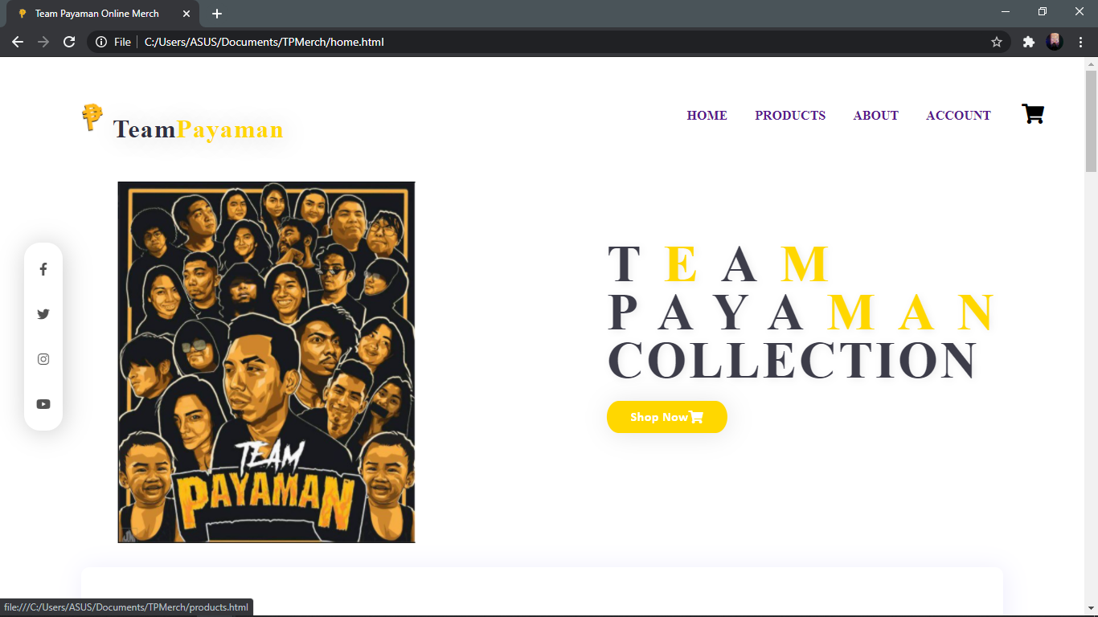**USER INTERFACE**

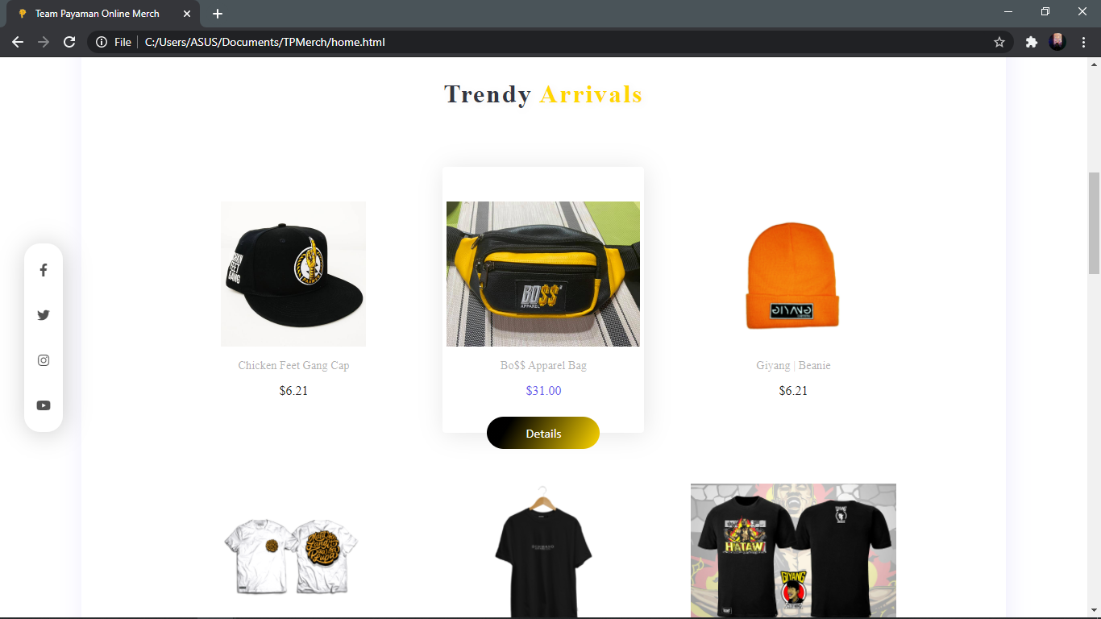

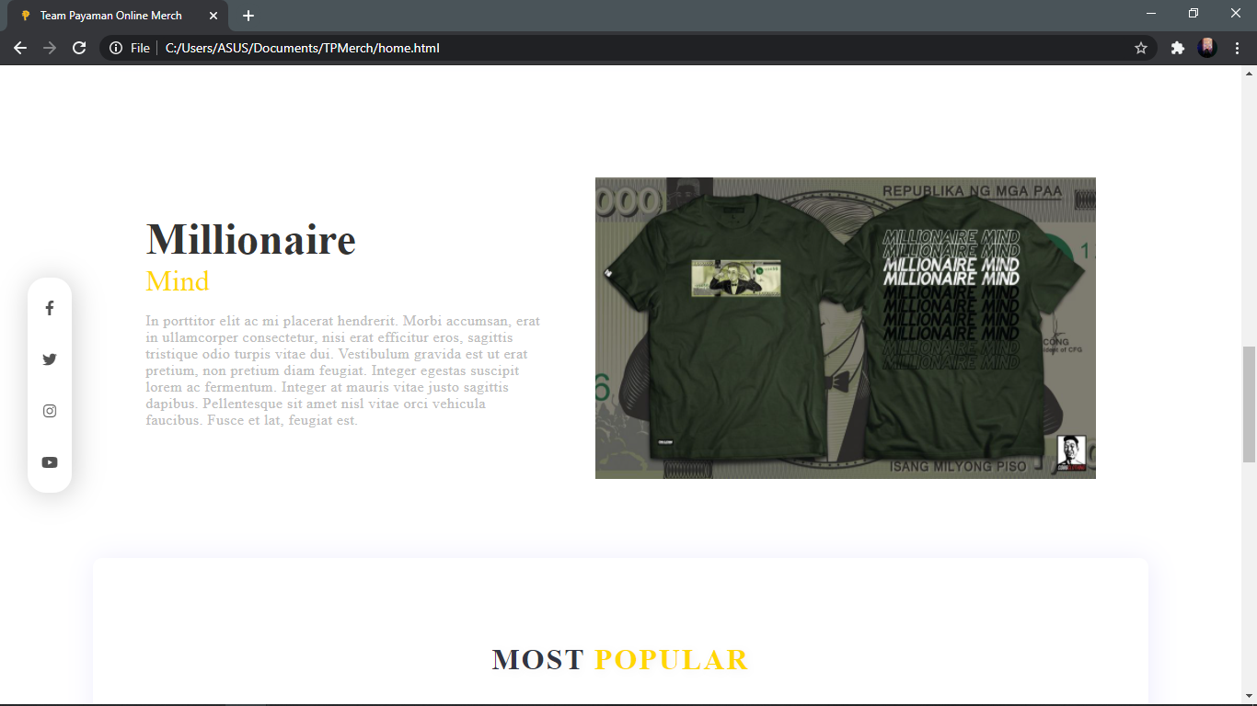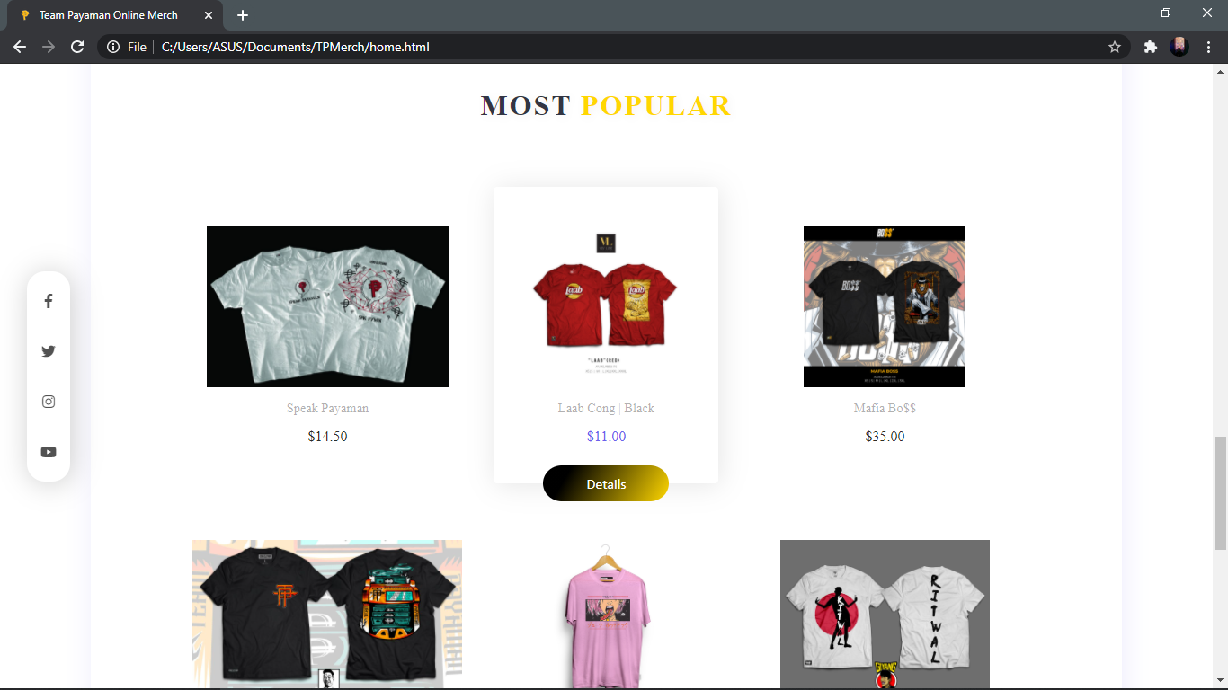

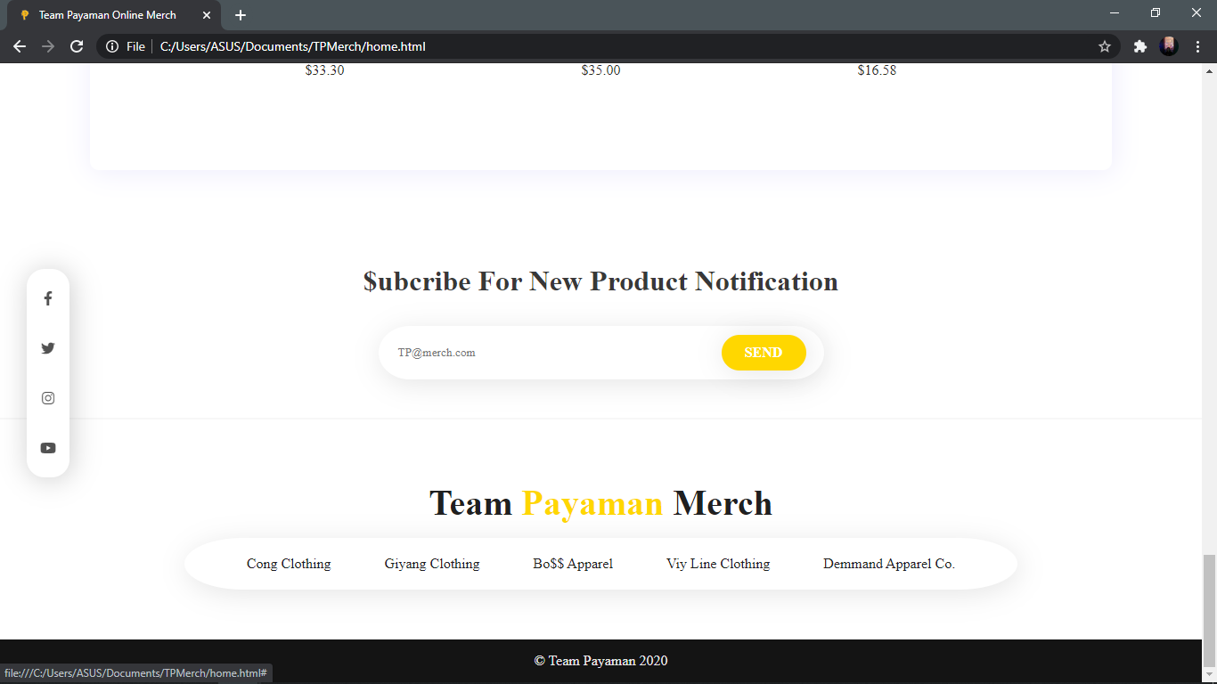

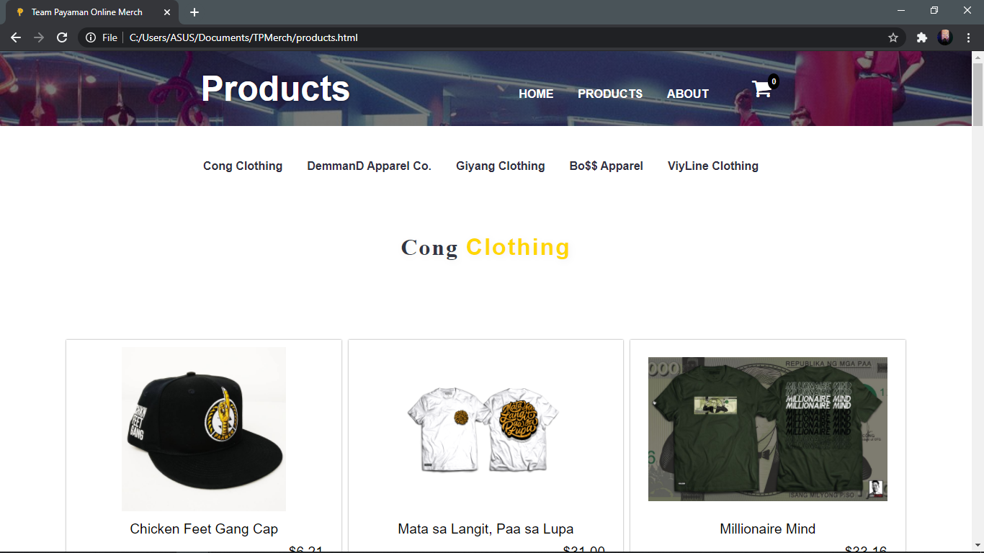

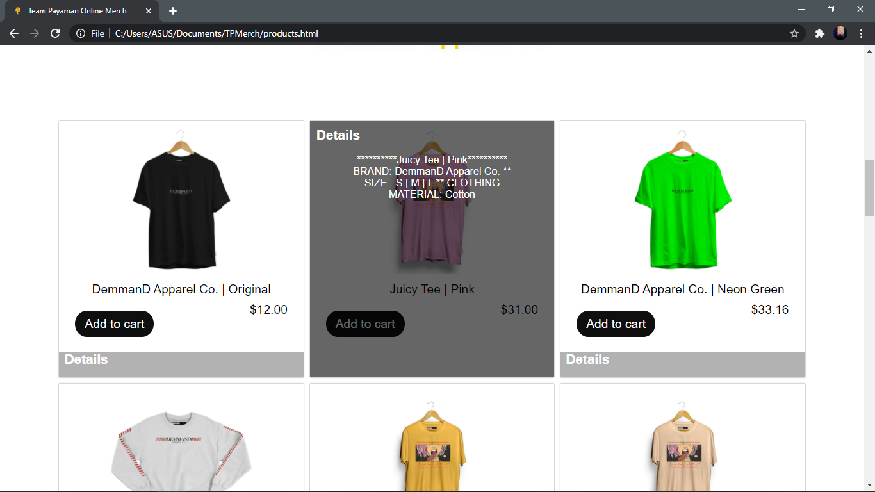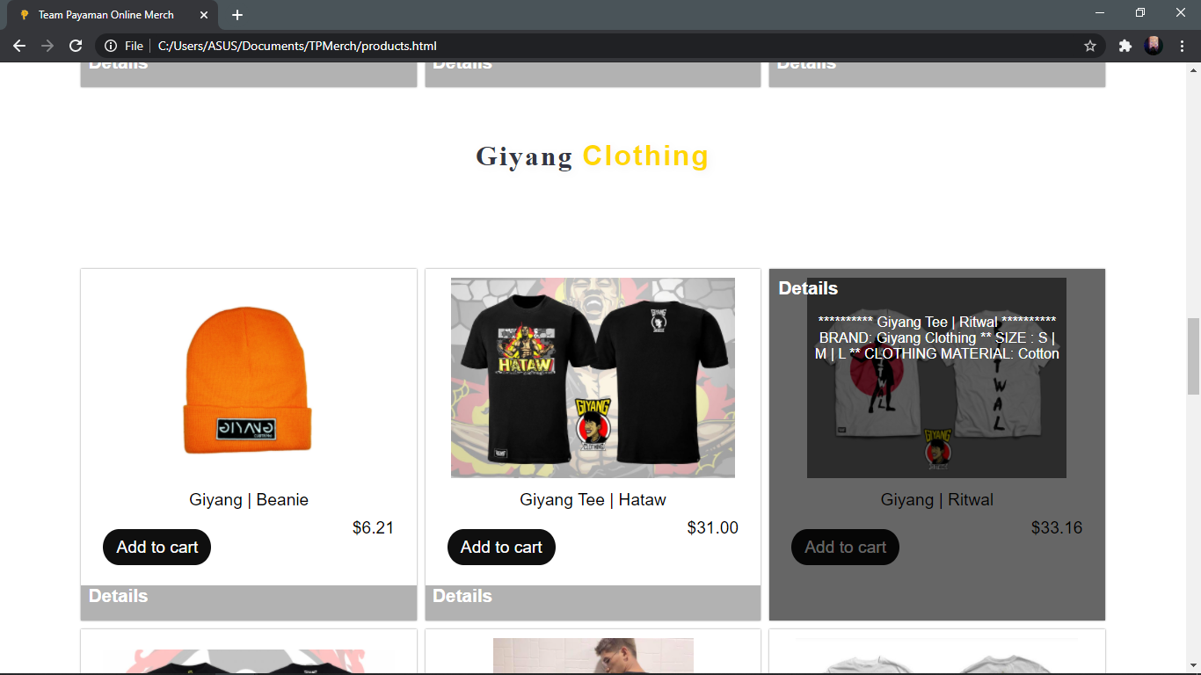

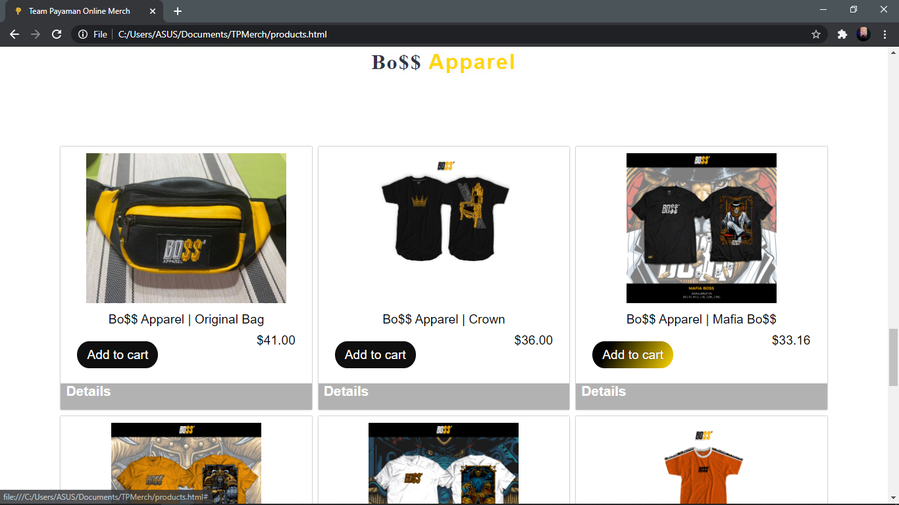

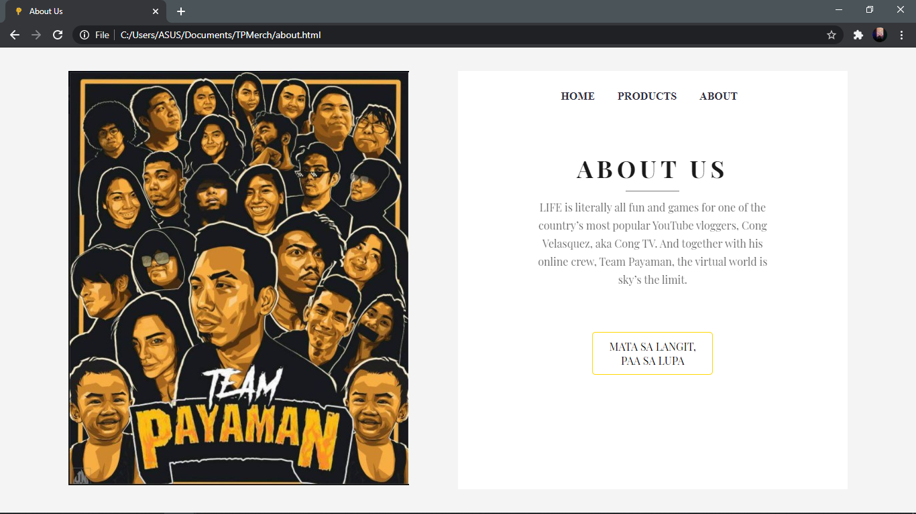

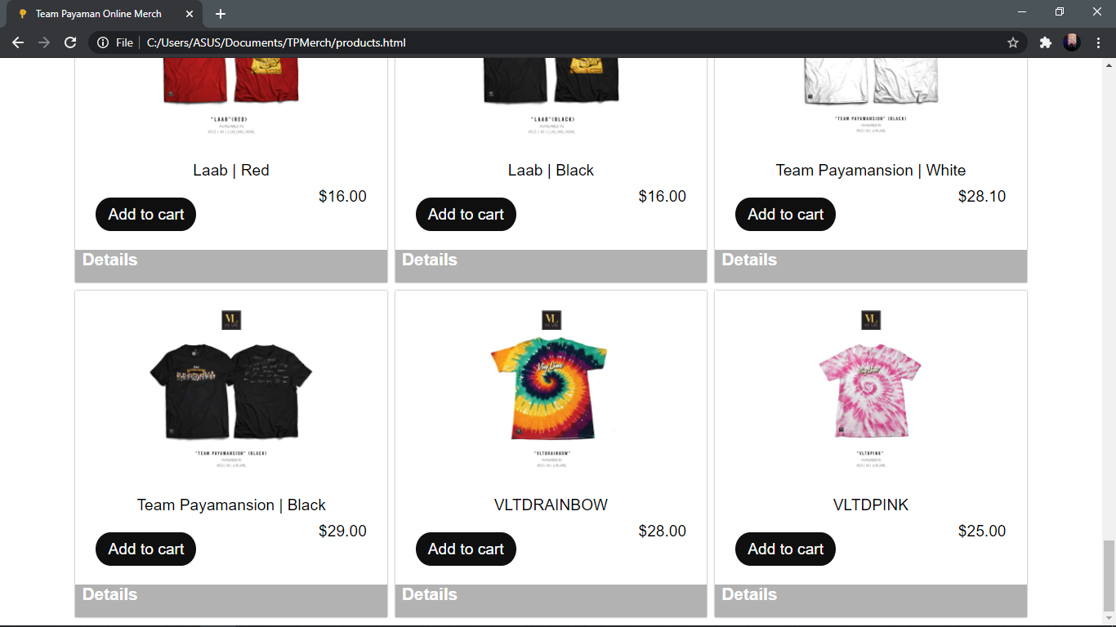

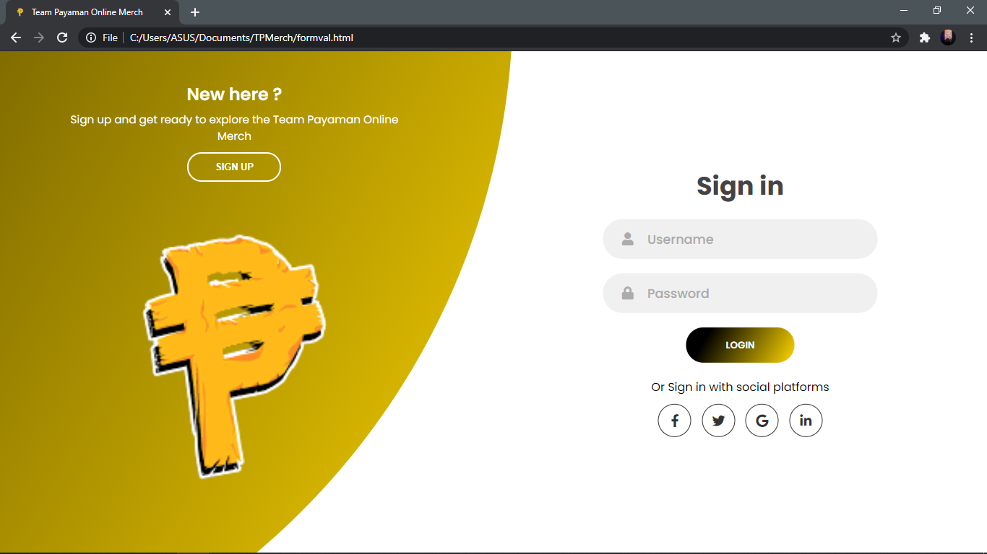

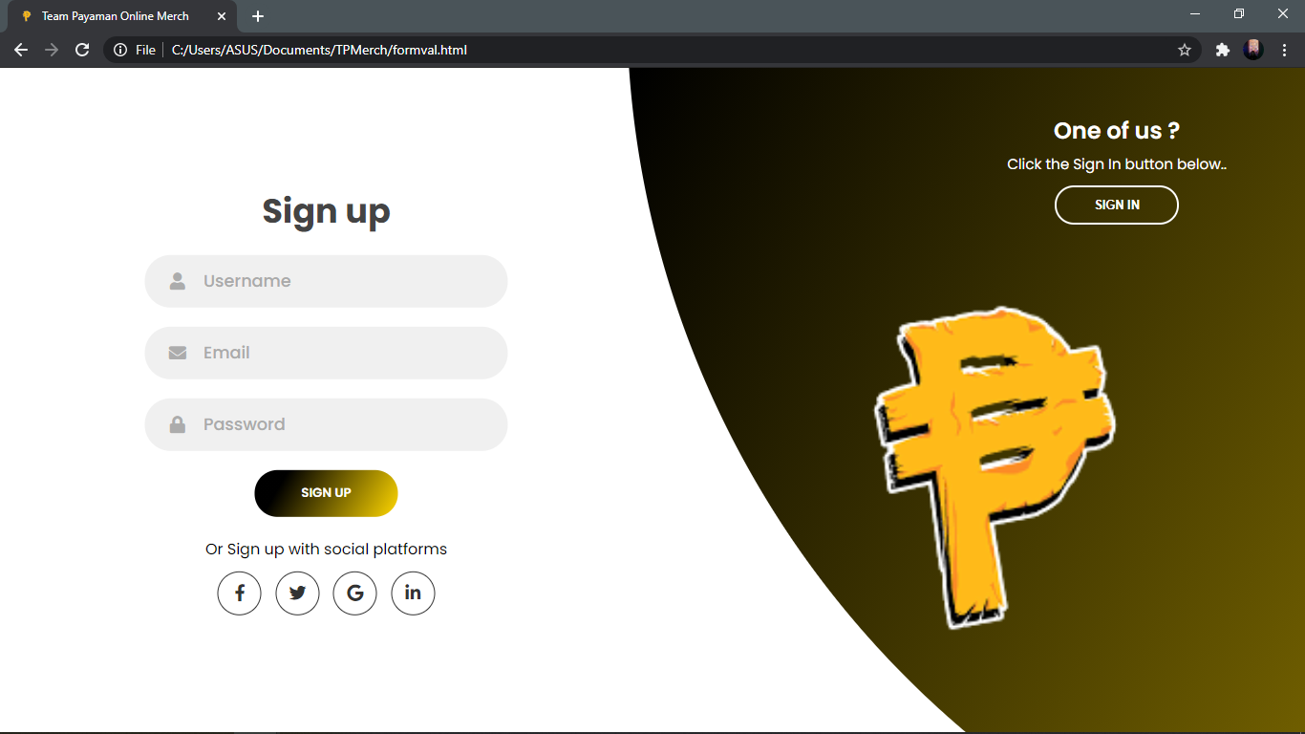

**SOURCE CODE**

**Home.html**

<!DOCTYPE html>

<html lang="en">

<html>

<head>

<meta charset="utf-8"/>

<title>Team Payaman Online Merch</title>

<link href="img/tplogo.png" rel="shortcut icon"/>

<link href="css/trystyle.css" rel="stylesheet" type="text/css"/>

<link rel="stylesheet" href="css/homestyle.css"/>

<script crossorigin="anonymous" src="https://kit.fontawesome.com/70a642cd7c.js"></script>

</head>

<body>

<section class="main">

<div class="logo">

<a href="home.html"><img src="img/tplogo.png" width="50px">Team<font>Payaman</font></a>

</div>

<div class="header">

<a href="home.html">HOME</a>

<a href="products.html">PRODUCTS</a>

<a href="about.html">ABOUT</a>

<a href="formval.html">ACCOUNT</a>

</div>

<div class="cart-icon">

<a class="cart-btn" href="#"><i class="fa fa-shopping-cart" style='font-size:25px'></i></a>

</div>

<div class="m-img">

<img alt="" src="img/maintp.jpg" />

</div>

<div class="m-text">

<h1>T<font>E</font>A<font>M</font><br>PAYA<font>MAN</font></h1>

<h2>CollectION</h2>

<a class="m-btn" href="products.html">Shop Now<i class="fas fa-shopping-cart"></i></a>

</div>

<div class="social">

<a href="https://www.facebook.com/congTVclothing/"><i class="fab fa-facebook-f"></i></a>

<a href="https://twitter.com/TheCongTV"><i class="fab fa-twitter"></i></a>

<a href="https://www.instagram.com/thecongtv/"><i class="fab fa-instagram"></i></a>

<a href="https://www.Youtube.com/lincolnvelasquez"><i class="fab fa-youtube"></i></a>

</div>

</section>

<section class="product">

<div class="p-heading">

<a name="products"></a>

<h3>Trendy <font>Arrivals</font></h3>

</div>

<div class="product-container">

<div class="p-box">

<img alt="1" src="img/cong/cong1.png" />

<p>Chicken Feet Gang Cap</p>

<a class="price" href="#">$6.21</a>

<a class="buy-btn" href="#">Details</a>

</div>

<div class="p-box">

<img alt="2" src="img/keng/keng1.jpg" />

<p>Bo$$ Apparel Bag</p>

<a class="price" href="#">$31.00</a>

<a class="buy-btn" href="#">Details</a>

</div>

<div class="p-box">

<img alt="3" src="img/giyang/giyang1.jpg" />

<p>Giyang | Beanie</p>

<a class="price" href="#">$6.21</a>

<a class="buy-btn" href="#">Details</a>

</div>

<div class="p-box">

<img alt="4" src="img/cong/cong2.png" />

<p>Mata sa Langit, Paa sa Lupa</p>

<a class="price" href="#">$12.44</a>

<a class="buy-btn" href="#">Details</a>

</div>

<div class="p-box">

<img alt="5" src="img/emman/emman1.png" />

<p>Demmand Original</p>

<a class="price" href="#">$33.16</a>

<a class="buy-btn" href="#">Details</a>

</div>

<div class="p-box">

<img alt="6" src="img/giyang/giyang2.jpg" />

<p>Giyang | Hataw</p>

<a class="price" href="#">$12.44</a>

<a class="buy-btn" href="#">Details</a>

</div>

</div>

</section>

<section class="our-brand">

<div class="brand-text">

<h3>Millionaire</h3>

<h4><font>Mind</font></h4>

<p>In porttitor elit ac mi placerat hendrerit. Morbi accumsan, erat in ullamcorper consectetur, nisi erat efficitur eros, sagittis tristique odio turpis vitae dui. Vestibulum gravida est ut erat pretium, non pretium diam feugiat. Integer egestas suscipit lorem ac fermentum. Integer at mauris vitae justo sagittis dapibus. Pellentesque sit amet nisl vitae orci vehicula faucibus. Fusce et lat, feugiat est.</p>

</div>

<div class="brand-img"><img src="img/cong/cong3.jpg" /></div>

</section>

<section class="product">

<div class="p-heading">

<h3>MOST <font>POPULAR</font></h3>

</div>

<div class="product-container">

<div class="p-box">

<img alt="1" src="img/cong/cong4.jpg" />

<p>Speak Payaman</p>

<a class="price" href="#">$14.50</a>

<a class="buy-btn" href="#">Details</a>

</div>

<div class="p-box">

<img alt="2" src="img/viy/viy1.jpg" />

<p>Laab Cong | Black</p>

<a class="price" href="#">$11.00</a>

<a class="buy-btn" href="#">Details</a>

</div>

<div class="p-box">

<img alt="3" src="img/keng/keng3.jpg" />

<p>Mafia Bo$$</p>

<a class="price" href="#">$35.00</a>

<a class="buy-btn" href="#">Details</a>

</div>

<div class="p-box">

<img alt="4" src="img/cong/cong6.jpg" />

<p>Team Payaman Million</p>

<a class="price" href="#">$33.30</a>

<a class="buy-btn" href="#">Details</a>

</div>

<div class="p-box">

<img alt="5" src="img/emman/emman2.jpg" />

<p>Demmand Apparel | Juicy Hotdog</p>

<a class="price" href="#">$35.00</a>

<a class="buy-btn" href="#">Details</a>

</div>

<div class="p-box">

<img alt="6" src="img/giyang/giyang3.jpg" />

<p>Giyang | Ritwal</p>

<a class="price" href="#">$16.58</a>

<a class="buy-btn" href="#">Details</a>

</div>

</div>

</section>

<section class="subcribe-container">

<h3>$ubcribe For New Product Notification</h3>

<div class="subcribe-input">

<input placeholder="TP@merch.com" type="email" />

<a class="subcribe-btn" href="#">Send</a>

</div>

</section>

<footer>

<h3>Team <font>Payaman </font>Merch</h3>

<ul class="footer-menu">

<li><a href="https://www.facebook.com/congTVclothing/">Cong Clothing</a></li>

<li><a href="https://www.facebook.com/GiyangClothing">Giyang Clothing</a></li>

<li><a href="https://www.facebook.com/bosskengapparel">Bo$$ Apparel</a></li>

<li><a href="https://www.facebook.com/ViyLine/">Viy Line Clothing</a></li>

<li><a href="https://www.facebook.com/DEMMAND">Demmand Apparel Co.</a></li>

</ul>

</footer>

<a class="copyright" href="#">&#169; Team Payaman 2020</a>

<script src="js/index.js"></script>

</body>

</html>

**Homestyle.css**

body{

margin:0px;

padding: 0px;

}

*{

box-sizing: border-box;

font-family: myriad pro;

}

a{

text-decoration:none;

}

ul{

list-style:none;

}

.main{

width:100%;

height: 100vh;

background-image: url("../images/poduct%20bg.png");

background-size:800px;

background-position: center;

position: relative;

}

.logo{

position: absolute;

left: 90px;

top: 50px;

}

.logo a{

font-family:poppins;

font-weight: bold;

color: #2f2e41;

font-size:2rem;

text-shadow: 2px 2px 30px rgba(0,0,0,0.2);

letter-spacing: 1px;

}

.logo font{

color:#FFD700;

}

.header {

position: absolute;

top: 63px;

right: 100px;

font-family: poppins;

font-weight: bold;

color: #2f2e41;

font-size:1rem;

padding: 1px;

}

.header a{

text-decoration: none;

margin: 15px;

}

.header a:hover {

color: #FFD700;

}

.side-box{

position: fixed;

right: 90px;

top: 50px;

width:170px;

height: 45px;

background-color: #FFFFFF;

display: flex;

justify-content:center;

align-items: center;

border-radius: 10% 10% 10% 10% / 50% 50% 50% 50%;

box-shadow: 2px 2px 30px rgba(167, 158, 245, 0.2);

box-sizing: border-box;

z-index: 1;

border:1px solid rgba(167, 158, 245, 0.1);

}

.search input{

width: 90px;

height: 20px;

border: none;

outline: none;

background-color: transparent;

color: #1F1F1F;

font-family: calibri;

font-size: 1rem;

padding: 0px 10px;

}

.search input::placeholder{

color: #1D1D1D;

font-weight:400;

letter-spacing: 2px;

font-size: 0.8rem;

font-family: poppins;

}

.search i{

margin: 0px auto;

}

.cart-icon{

text-align: right;

}

.cart-icon i{

margin-right: 50px;

margin-top: 58px;

text-align: right;

}

.cart-btn{

color:#000000;

}

.cart-btn:hover{

color: #FFD700;

transition: all ease 0.5s;

}

.m-img{

position:absolute;

left:15%;

top: 55%;

transform: translate(-15%,-50%);

}

.m-img img{

height:450px;

}

.m-text{

position: absolute;

top: 50%;

left:90%;

transform: translate(-90%,-50%);

}

.m-text h1,h2{

font-family:Roboto;

font-weight: bold;

margin: 0px;

line-height: 60px;

font-size: 4rem;

text-shadow: 2px 2px 10px rgba(0,0,0,0.08);

letter-spacing: 3px;

color:#3D3D4A;

text-transform: uppercase;

}

.m-text h1{

letter-spacing:28px;

}

.m-text h1 font,

.m-text h2 font{

color:#FFD700;

}

.m-btn{

width:150px;

height: 40px;

background-color: #2f2e41;

box-shadow: 2px 2px 30px rgba(0,0,0,0.1);

display: flex;

justify-content: center;

align-items: center;

border-radius: 10% 10% 10% 10% / 50% 50% 50% 50%;

margin-top: 20px;

color:#fff;

font-family: calibri;

font-weight: 600;

letter-spacing: 0.5px;

font-size: 1rem;

}

.m-btn:hover{

color:#FFFFFF;

background-color: #FFD700;

transition: all ease 0.5s;

}

.social a{

display: flex;

flex-direction: column;

justify-content: center;

align-items: center;

padding: 20px 15px;

}

.social{

position:fixed;

left: 30px;

top: 50%;

transform: translateY(-50%);

border-radius: 20px;

background-color: #FFFFFF;

box-shadow: 2px 2px 30px rgba(0,0,0,0.2);

padding: 5px 0px;

z-index: 1;

}

.social a i{

color:rgba(39,39,39,0.80);

}

.social a:hover .fa-facebook-f{

color: #3b5998;

}

.social a:hover .fa-twitter{

color: #00acee ;

}

.social a:hover .fa-instagram{

color: #3f729b ;

}

.social a:hover .fa-youtube{

color: #FF0000;}

.product{

width: 85%;

background-color: #FFFFFF;

box-shadow: 2px 2px 30px rgba(167, 158, 245, 0.2);

display: flex;

margin:30px auto;

flex-direction: column;

align-items: center;

padding:40px 20px;

margin-top: -60px;

position: relative;

background-image: url("../images/poduct bg.png");

background-size:1000px;

background-position: center;

border-radius: 10px;

}

.p-heading{

margin:20px;

text-shadow: 2px 2px 10px rgba(0,0,0,0.05);

}

.p-heading h3{

font-family: myriad pro;

font-weight: 700;

letter-spacing: 2px;

text-align: center;

font-size:2rem;

color:#323543;

}

.p-heading h3 font{

color:#FFD700;

}

.product-container{

display: flex;

justify-content: center;

align-items: center;

flex-wrap: wrap;

margin: 10px 0px;

width:100%;

}

.p-box{

width:250px;

height: 330px;

display: flex;

justify-content: center;

align-items: center;

flex-direction: column;

border-radius: 4px;

position: relative;

margin: 10px 30px;

}

.p-box img{

height:180px;

}

.p-box p{

color:#4d4d4d70;

font-family: myriad pro;

font-size: 0.9rem;

letter-spacing: 0.5;

}

.price{

color:#2c2c2c;

font-family: poppins;

font-size: 1rem;;

}

.buy-btn{

position: absolute;

width:140px;

height: 40px;

display: flex;

justify-content: center;

align-items: center;

font-family:calibri;

left: 50%;

bottom: -20px;

transform: translateX(-50%);

border-radius: 15% 15% 15% 15% / 50% 50% 50% 50%;

background:linear-gradient(120deg,#000000 20%,#FFD700);

color:#FFFFFF;

display: none;

animation: fade 0.2s;

}

.p-box:hover .buy-btn{

display: flex;

}

.p-box:hover{

box-shadow: 2px 2px 30px rgba(0,0,0,0.1);

background-color:#FFFFFF;

}

.p-box:hover .price{

color:#6b60ec;

transition: all ease 0.2s;

}

@keyframes fade{

0%{

opacity: 0;

}

100%{

opacity: 1;

}

}

.our-brand{

display: flex;

width: 85%;

margin:30px auto;

justify-content: space-around;

align-items: center;

padding:30px;

}

.brand-text{

width:40%;

font-family:myriad pro;}

.brand-img{

height: 500px;

width: 50%;

box-sizing: border-box;

}

.brand-img img{

width:100%;

height: 100%;

object-fit:contain;

}

.brand-text h3{

color:#333333;

font-weight: 700;

font-size:3rem;

margin:0px;

}

.brand-text h4{

color: #333333;

font-weight: 400;

font-size:2rem;

margin:0px;

}

.brand-text font{

color:#FFD700;

}

.brand-text p{

font-size: 1rem;

color:#bdbdbd;

letter-spacing: 0.5px;

}

.subcribe-container{

width:100%;

height:250px;

margin-bottom:30px;

display: flex;

flex-direction: column;

justify-content: center;

align-items: center;

border-bottom: 2px solid rgba(0,0,0,0.03);

}

.subcribe-container h3{

font-size: 2rem;

color: rgb(56, 56, 56);

}

.subcribe-input{

width:500px;

background-color: #fff;

border-radius: 7% 7% 7% 7% / 50% 50% 50% 50%;

height: 60px;

display: flex;

justify-content: center;

align-items: center;

padding:20px;

box-shadow: 2px 5px 30px rgba(0,0,0,0.1);

}

.subcribe-input input{

width:100%;

height: 40px;

border: none;

outline: none;

background-color: transparent;

}

.subcribe-btn{

width:120px;

height: 40px;

background-color: #202020;

border-radius: 20px;

color: #fff;

display: flex;

justify-content: center;

align-items: center;

text-transform: uppercase;

font-weight: bold;

box-shadow: 2px 2px 30px rgba(0,0,0,0.1);

font-size: 1rem;

}

.subcribe-btn:hover{

background-color:#FFD700;

transition: all ease 0.5s;

}

footer{

display: flex;

flex-direction: column;

justify-content: center;

align-items: center;

padding: 40px;

background-image: url("../images/poduct bg.png");

background-size:400px;

background-position: center;

border-radius: 10px;

}

footer h3{

font-size: 2.5rem;

color: #202020;

margin:0px;

}

footer h3 font{

color:#FFD700;

}

.footer-menu{

display: flex;

box-shadow: 2px 5px 30px rgba(0,0,0,0.1);

background-color: #fff;

border-radius: 7% 7% 7% 7% / 50% 50% 50% 50%;

justify-content: center;

align-items: center;

padding:5px 40px;

}

.footer-menu li a{

padding:5px 20px;

margin: 10px;

display: flex;

color:#202020;

}

.footer-menu li a:hover{

color:#FFD700;

}

.copyright{

color:#e7e7e7;

background-color: #141414;

display: flex;

justify-content: center;

align-items: center;

padding: 15px;

}

@media(max-width:1230px){

.m-img img{

height: 350px;

}

.m-text h1,h2{

font-size:3.5rem;

}

}

@media(max-width:1045px){

.main{

background-size: 600px;

}

.m-img{

display:none;

}

.m-text{

left:50%;

top:50%;

transform: translate(-50%,-50%);

}

.our-brand{

flex-direction:column-reverse;

}

.brand-text,.brand-img{

width:100%;

}

.brand-img{

height:300px;

margin:20px;

}

}

@media(max-width:600px){

.social{

display: none;

}

.logo{

left: 30px;

top:30px;

}

.logo a{

font-size: 1.4rem;;

}

.side-box{

right:30px;

top:30px;

}

.m-text{

overflow-wrap: break-word;

display: flex;

flex-direction: column;

margin:auto;

}

.m-text h1,h2{

font-size: 2.5rem;

line-height:40px;

margin:0px 20px;

letter-spacing: 10px;

}

.m-text h2{

font-size: 1.2rem;

}

.m-btn{

margin:0px 20px;

}

.product{

width:88%;

}

.p-box{

margin:20px 10px;

padding:10px 20px;

width:100%;

text-align: center;

}

.subcribe-input{

width:95%;

}

.subcribe-container h3{

font-size:1.4rem;

text-align: center;

}

.footer-menu{

width:100%;

margin:20px;

flex-wrap: wrap;

background-color:none;

box-shadow: none;

}

.footer-menu li a{

background-color:#fff;

border-radius: 20px;

box-shadow:2px 2px 30px rgba(0, 0, 0, 0.1) ;

padding:10px 30px !important;

}

.copyright {

text-align: center;

}

}

**Products.html**

<!DOCTYPE html>

<html>

<head>

<title>Team Payaman Online Merch</title>

<link href="img/tplogo.png" rel="shortcut icon"/>

<link rel="stylesheet" href="css/products.css"/>

<link rel="stylesheet" type="text/css" href="https://stackpath.bootstrapcdn.com/font-awesome/4.7.0/css/font-awesome.min.css"/>

</head>

<body>

<div class="main">

<header id="header" class="header">

<h1>Products</h1>

<div class="shopCart">

<p>0</p>

<i class="fa fa-shopping-cart"></i>

</div>

</header>

<div class="headerhead">

<a href="home.html">HOME</a>

<a href="#products">PRODUCTS</a>

<a href="about.html">ABOUT</a>

</div>

<div class="select">

<a href="#cc">Cong Clothing</a>

<a href="#da">DemmanD Apparel Co.</a>

<a href="#gc">Giyang Clothing</a>

<a href="#ba">Bo$$ Apparel</a>

<a href="#vl">ViyLine Clothing</a>

</div>

<div class="p-heading">

<a id="cc" name="products"></a>

<h1>Cong <font>Clothing</font></h1>

</div>

<div class="itemsBox">

<div class="item">

<img src="img/cong/cong1.png" alt="Chicken Feet Gang Cap"/>

<div class="itemInfo">

<h1>Chicken Feet Gang Cap</h1>

<p>$<span>6.21</span></p>

<a href="#" title="add to cart" class="xaddToCart">Add to cart</a>

<div class="textOverImage" data-title="Details" data-text="

****** Chicken Feet Gang Cap ******

BRAND: Cong Clothing ** CLOTHING MATERIAL: Other Material">

</div>

</div>

</div>

<div class="item">

<img src="img/cong/cong2.png" alt="Mata sa Langit, Paa sa Lupa" />

<div class="itemInfo">

<h1>Mata sa Langit, Paa sa Lupa</h1>

<p>$<span>31.00</span></p>

<a href="#" title="add to cart" class="xaddToCart">Add to cart</a>

<div class="textOverImage" data-title="Details" data-text="

***** Mata sa Langit, Paa sa Lupa *****

BRAND: Cong Clothing ** SIZE : S | M | L ** CLOTHING MATERIAL: Cotton">

</div>

</div>

</div>

<div class="item">

<img src="img/cong/cong3.jpg" alt="Millionaire Mind" />

<div class="itemInfo">

<h1>Millionaire Mind</h1>

<p>$<span>33.16</span></p>

<a href="#" title="add to cart" class="xaddToCart">Add to cart</a>

<div class="textOverImage" data-title="Details" data-text="

************ Millionaire Mind ************

BRAND: Cong Clothing ** SIZE : S | M | L ** CLOTHING MATERIAL: Cotton">

</div>

</div>

</div>

<div class="item">

<img src="img/cong/cong4.jpg" alt="Speak Payaman" />

<div class="itemInfo">

<h1>Speak Payaman</h1>

<p>$<span>25.00</span></p>

<a href="#" title="add to cart" class="xaddToCart">Add to cart</a>

<div class="textOverImage" data-title="Details" data-text="

************Speak Payaman************

BRAND: Cong Clothing ** SIZE : S | M | L ** CLOTHING MATERIAL: Cotton">

</div>

</div>

</div>

<div class="item">

<img src="img/cong/cong5.jpg" alt="Team Payaman Millionaire" />

<div class="itemInfo">

<h1>Team Payaman Millionaire</h1>

<p>$<span>33.16</span></p>

<a href="#" title="add to cart" class="xaddToCart">Add to cart</a>

<div class="textOverImage" data-title="Details" data-text="

*******Team Payaman Millionaire*******

BRAND: Cong Clothing ** SIZE : S | M | L ** CLOTHING MATERIAL: Cotton">

</div>

</div>

</div>

<div class="item">

<img src="img/cong/cong6.jpg" alt="Team Payaman Million" />

<div class="itemInfo">

<h1>Team Payaman Million</h1>

<p>$<span>33.16</span></p>

<a href="#" title="add to cart" class="xaddToCart">Add to cart</a>

<div class="textOverImage" data-title="Details" data-text="

*********Team Payaman Million*********

BRAND: Cong Clothing ** SIZE : S | M | L ** CLOTHING MATERIAL: Cotton">

</div>

</div>

</div>

</div>

<!----------------EMMAN-------------------->

<div class="p-heading">

<a id="da" name="products"></a>

<h1>DemmanD <font>Apparel</font> Co.</h1>

</div>

<div class="itemsBox">

<div class="item">

<img src="img/emman/emman1.png" alt="DemmanD Apparel Co. | Original"/>

<div class="itemInfo">

<h1>DemmanD Apparel Co. | Original</h1>

<p>$<span>12.00</span></p>

<a href="#" title="add to cart" class="xaddToCart">Add to cart</a>

<div class="textOverImage" data-title="Details" data-text="

***DemmanD Apparel Co. | Original***

BRAND: DemmanD Apparel Co. ** SIZE : S | M | L ** CLOTHING MATERIAL: Cotton">

</div>

</div>

</div>

<div class="item">

<img src="img/emman/emman2.jpg" alt="Juicy Tee | Pink" />

<div class="itemInfo">

<h1>Juicy Tee | Pink</h1>

<p>$<span>31.00</span></p>

<a href="#" title="add to cart" class="xaddToCart">Add to cart</a>

<div class="textOverImage" data-title="Details" data-text="

**********Juicy Tee | Pink**********

BRAND: DemmanD Apparel Co. ** SIZE : S | M | L ** CLOTHING MATERIAL: Cotton">

</div>

</div>

</div>

<div class="item">

<img src="img/emman/emman3.jpg" alt="DemmanD Apparel Co. | Neon Green" />

<div class="itemInfo">

<h1>DemmanD Apparel Co. | Neon Green</h1>

<p>$<span>33.16</span></p>

<a href="#" title="add to cart" class="xaddToCart">Add to cart</a>

<div class="textOverImage" data-title="Details" data-text="

*DemmanD Apparel Co. | Neon Green*

BRAND: DemmanD Apparel Co. ** SIZE : S | M | L ** CLOTHING MATERIAL: Cotton">

</div>

</div>

</div>

<div class="item">

<img src="img/emman/emman4.jpg" alt="Rising Sun Signature | White" />

<div class="itemInfo">

<h1>Rising Sun Signature | White</h1>

<p>$<span>45.00</span></p>

<a href="#" title="add to cart" class="xaddToCart">Add to cart</a>

<div class="textOverImage" data-title="Details" data-text="

******Rising Sun Signature | White******

BRAND: DemmanD Apparel Co. ** SIZE : S | M | L ** CLOTHING MATERIAL: Cotton">

</div>

</div>

</div>

<div class="item">

<img src="img/emman/emman5.jpg" alt="Juicy Tee | Gold" />

<div class="itemInfo">

<h1>Juicy Tee | Gold</h1>

<p>$<span>33.16</span></p>

<a href="#" title="add to cart" class="xaddToCart">Add to cart</a>

<div class="textOverImage" data-title="Details" data-text="

**********Juicy Tee | Gold**********

BRAND: DemmanD Apparel Co. ** SIZE : S | M | L ** CLOTHING MATERIAL: Cotton">

</div>

</div>

</div>

<div class="item">

<img src="img/emman/emman6.jpg" alt="Juicy Tee | Beige" />

<div class="itemInfo">

<h1>Juicy Tee | Beige</h1>

<p>$<span>33.16</span></p>

<a href="#" title="add to cart" class="xaddToCart">Add to cart</a>

<div class="textOverImage" data-title="Details" data-text="

**********Juicy Tee | Beige**********

BRAND: DemmanD Apparel Co. ** SIZE : S | M | L ** CLOTHING MATERIAL: Cotton">

</div>

</div>

</div>

</div>

<!-------------------JUNNNIE------------------------->

<div class="p-heading">

<a id="gc" name="products"></a>

<h1>Giyang <font>Clothing</font></h1>

</div>

<div class="itemsBox">

<div class="item">

<img src="img/giyang/giyang1.jpg" alt="Giyang | Beanie"/>

<div class="itemInfo">

<h1>Giyang | Beanie</h1>

<p>$<span>6.21</span></p>

<a href="#" title="add to cart" class="xaddToCart">Add to cart</a>

<div class="textOverImage" data-title="Details" data-text="

******** Giyang | Beanie ********

BRAND: Giyang Clothing ** CLOTHING MATERIAL: Other Material">

</div>

</div>

</div>

<div class="item">

<img src="img/giyang/giyang2.jpg" alt="Giyang Tee | Hataw" />

<div class="itemInfo">

<h1>Giyang Tee | Hataw</h1>

<p>$<span>31.00</span></p>

<a href="#" title="add to cart" class="xaddToCart">Add to cart</a>

<div class="textOverImage" data-title="Details" data-text="

********** Giyang Tee | Hataw **********

BRAND: Giyang Clothing ** SIZE : S | M | L ** CLOTHING MATERIAL: Cotton">

</div>

</div>

</div>

<div class="item">

<img src="img/giyang/giyang3.jpg" alt="Giyang | Ritwal" />

<div class="itemInfo">

<h1>Giyang | Ritwal</h1>

<p>$<span>33.16</span></p>

<a href="#" title="add to cart" class="xaddToCart">Add to cart</a>

<div class="textOverImage" data-title="Details" data-text="

********** Giyang Tee | Ritwal **********

BRAND: Giyang Clothing ** SIZE : S | M | L ** CLOTHING MATERIAL: Cotton">

</div>

</div>

</div>

<div class="item">

<img src="img/giyang/giyang4.jpg" alt="Giyang | Yin Yang" />

<div class="itemInfo">

<h1>Giyang | Yin Yang</h1>

<p>$<span>31.00</span></p>

<a href="#" title="add to cart" class="xaddToCart">Add to cart</a>

<div class="textOverImage" data-title="Details" data-text="

****** Giyang | Yin Yang ******

BRAND: Giyang Clothing ** SIZE : S | M | L ** CLOTHING MATERIAL: Cotton">

</div>

</div>

</div>

<div class="item">

<img src="img/giyang/giyang5.jpg" alt="Giyang | Long Tee" />

<div class="itemInfo">

<h1>Giyang | Long Tee</h1>

<p>$<span>33.16</span></p>

<a href="#" title="add to cart" class="xaddToCart">Add to cart</a>

<div class="textOverImage" data-title="Details" data-text="

********** Giyang | Long Tee **********

BRAND: Giyang Clothing ** SIZE : S | M | L ** CLOTHING MATERIAL: Cotton">

</div>

</div>

</div>

<div class="item">

<img src="img/giyang/giyang6.jpg" alt="Giyang | It's Tiiime!" />

<div class="itemInfo">

<h1>Giyang | It's Tiiime!</h1>

<p>$<span>30.00</span></p>

<a href="#" title="add to cart" class="xaddToCart">Add to cart</a>

<div class="textOverImage" data-title="Details" data-text="

**********Giyang | It's Tiiime!**********

BRAND: Giyang Clothing ** SIZE : S | M | L ** CLOTHING MATERIAL: Cotton">

</div>

</div>

</div>

</div>

<!----------------KENG-------------------->

<div class="p-heading">

<a id="ba" name="products"></a>

<h1>Bo$$ <font>Apparel</font></h1>

</div>

<div class="itemsBox">

<div class="item">

<img src="img/keng/keng1.jpg" alt="Bo$$ Apparel | Original Bag"/>

<div class="itemInfo">

<h1>Bo$$ Apparel | Original Bag</h1>

<p>$<span>41.00</span></p>

<a href="#" title="add to cart" class="xaddToCart">Add to cart</a>

<div class="textOverImage" data-title="Details" data-text="

******Bo$$ Apparel | Original Bag******

BRAND: Bo$$ Apparel ** SIZE : S | M | L ** CLOTHING MATERIAL: Cotton">

</div>

</div>

</div>

<div class="item">

<img src="img/keng/keng2.jpg" alt="Bo$$ Apparel | Crown" />

<div class="itemInfo">

<h1>Bo$$ Apparel | Crown</h1>

<p>$<span>36.00</span></p>

<a href="#" title="add to cart" class="xaddToCart">Add to cart</a>

<div class="textOverImage" data-title="Details" data-text="

**********Bo$$ Apparel | Crown**********

BRAND: Bo$$ Apparel ** SIZE : S | M | L ** CLOTHING MATERIAL: Cotton">

</div>

</div>

</div>

<div class="item">

<img src="img/keng/keng3.jpg" alt="Bo$$ Apparel | Mafia Bo$$" />

<div class="itemInfo">

<h1>Bo$$ Apparel | Mafia Bo$$</h1>

<p>$<span>33.16</span></p>

<a href="#" title="add to cart" class="xaddToCart">Add to cart</a>

<div class="textOverImage" data-title="Details" data-text="

****Bo$$ Apparel | Mafia Bo$$****

BRAND: Bo$$ Apparel ** SIZE : S | M | L ** CLOTHING MATERIAL: Cotton">

</div>

</div>

</div>

<div class="item">

<img src="img/keng/keng4.jpg" alt="Bo$$ Apparel | Viking Bo$$" />

<div class="itemInfo">

<h1>Bo$$ Apparel | Viking Bo$$</h1>

<p>$<span>39.50</span></p>

<a href="#" title="add to cart" class="xaddToCart">Add to cart</a>

<div class="textOverImage" data-title="Details" data-text="

******Bo$$ Apparel | Viking Bo$$******

BRAND: Bo$$ Apparel ** SIZE : S | M | L ** CLOTHING MATERIAL: Cotton">

</div>

</div>

</div>

<div class="item">

<img src="img/keng/keng5.jpg" alt="Bo$$ Apparel | Pirate Bo$$" />

<div class="itemInfo">

<h1>Bo$$ Apparel | Pirate Bo$$</h1>

<p>$<span>35.16</span></p>

<a href="#" title="add to cart" class="xaddToCart">Add to cart</a>

<div class="textOverImage" data-title="Details" data-text="

*******Bo$$ Apparel | Pirate Bo$$*******

BRAND: Bo$$ Apparel ** SIZE : S | M | L ** CLOTHING MATERIAL: Cotton">

</div>

</div>

</div>

<div class="item">

<img src="img/keng/keng6.jpg" alt="Bo$$ Apparel | Long Tee" />

<div class="itemInfo">

<h1>Bo$$ Apparel | Long Tee</h1>

<p>$<span>34.16</span></p>

<a href="#" title="add to cart" class="xaddToCart">Add to cart</a>

<div class="textOverImage" data-title="Details" data-text="

*******Bo$$ Apparel | Long Tee*******

BRAND: Bo$$ Apparel ** SIZE : S | M | L ** CLOTHING MATERIAL: Cotton">

</div>

</div>

</div>

</div>

<!----------------viy-------------------->

<div class="p-heading">

<a id="vl" name="products"></a>

<h1>Viy <font>Line</font> Clothing</h1>

</div>

<div class="itemsBox">

<div class="item">

<img src="img/viy/viy1.jpg" alt="ViyLine | Laab | Red"/>

<div class="itemInfo">

<h1> Laab | Red</h1>

<p>$<span>16.00</span></p>

<a href="#" title="add to cart" class="xaddToCart">Add to cart</a>

<div class="textOverImage" data-title="Details" data-text="

****** Laab | Red******

BRAND: ViyLine ** SIZE : S | M | L ** CLOTHING MATERIAL: Cotton">

</div>

</div>

</div>

<div class="item">

<img src="img/viy/viy2.jpg" alt="ViyLine | Laab | Black" />

<div class="itemInfo">

<h1>Laab | Black</h1>

<p>$<span>16.00</span></p>

<a href="#" title="add to cart" class="xaddToCart">Add to cart</a>

<div class="textOverImage" data-title="Details" data-text="

******** Laab | Black ********

BRAND: ViyLine ** SIZE : S | M | L ** CLOTHING MATERIAL: Cotton">

</div>

</div>

</div>

<div class="item">

<img src="img/viy/viy3.jpg" alt="Team Payamansion | White" />

<div class="itemInfo">

<h1>Team Payamansion | White</h1>

<p>$<span>28.10</span></p>

<a href="#" title="add to cart" class="xaddToCart">Add to cart</a>

<div class="textOverImage" data-title="Details" data-text="

****Team Payamansion | White****

BRAND: ViyLine ** SIZE : S | M | L ** CLOTHING MATERIAL: Cotton">

</div>

</div>

</div>

<div class="item">

<img src="img/viy/viy4.jpg" alt="Team Payamansion | Black" />

<div class="itemInfo">

<h1>Team Payamansion | Black</h1>

<p>$<span>29.00</span></p>

<a href="#" title="add to cart" class="xaddToCart">Add to cart</a>

<div class="textOverImage" data-title="Details" data-text="

****s*** Team Payamansion | Black ******

BRAND: ViyLine ** SIZE : S | M | L ** CLOTHING MATERIAL: Cotton">

</div>

</div>

</div>

<div class="item">

<img src="img/viy/viy5.jpg" alt="VLTDRAINBOW" />

<div class="itemInfo">

<h1>VLTDRAINBOW</h1>

<p>$<span>28.00</span></p>

<a href="#" title="add to cart" class="xaddToCart">Add to cart</a>

<div class="textOverImage" data-title="Details" data-text="

********* VLTDRAINBOW *********

BRAND: ViyLine ** SIZE : S | M | L ** CLOTHING MATERIAL: Cotton">

</div>

</div>

</div>

<div class="item">

<img src="img/viy/viy6.jpg" alt="VLTDPINK" />

<div class="itemInfo">

<h1>VLTDPINK</h1>

<p>$<span>25.00</span></p>

<a href="#" title="add to cart" class="xaddToCart">Add to cart</a>

<div class="textOverImage" data-title="Details" data-text="

********* VLTDPINK *********

BRAND: ViyLine ** SIZE : S | M | L ** CLOTHING MATERIAL: Cotton">

</div>

</div>

</div>

</div>

<!------------------end---------------->

</div>

<a class="upp" href="#"><i class="fa fa-arrow-up" style='font-size:50px'></i></a>

<div class="cartBox">

<div class="cart">

<i class="fa fa-close"></i>

<h1>Cart</h1>

<table></table>

</div>

</div>

<script src="js/index.js"></script>

</body>

</html>

**Products.css**

html{

scroll-behavior: smooth;

}

.upp{

position: fixed;

width: 50px;

height: 50px;

bottom: 40px;

right: 20px;

color: black;

}

.upp:hover{

color: gold;

}

*{

margin:0;

padding: 0;

font-family: sans-serif;

}

.main{

position: relative;

width: 100%;

}

.main header{

position: relative;

height: 15vh;

width: 100%;

display: flex;

align-items: center;

justify-content: space-around;

background: linear-gradient(rgba(0, 0, 0, 0.5),rgba(0, 0, 0, 0.5)),url('https://i.pinimg.com/originals/8b/ec/37/8bec374b6ca11b0f52221a88752fe7f4.jpg');

background-size: cover;

background-position: center center;

font-size: 1.5rem;

color: #fff;

text-shadow: 0px 0px 5px rgba(0, 0, 0, 0.5);

}

.main header .shopCart{

cursor: pointer;

z-index: 1;

position: relative;

font-size: 1.8rem;

}

.main header .shopCart p{

position: absolute;

top: -5px;

right: -12px;

font-size: 0.69rem;

background-color: #000;

padding: 5px 5px;

border-radius: 50%;

}

.main .itemsBox{

top: 100px;

position: relative;

height: calc(100% - 15vh);

width: 90%;

margin:0 auto;

overflow: hidden;

display: grid;

grid-template-columns: auto auto auto;

grid-gap: 10px;

padding: 10px 25px;

}

.main .itemsBox .item{

position: relative;

height: 400px;

width: 100%;

overflow: hidden;

padding: 10px 25px;

box-shadow: 0px 0px 2px rgba(0, 0, 0, 0.5);

box-sizing: border-box;

}

.main .itemsBox .item img{

position: relative;

width: 100%;

height: 60%;

object-fit: contain;

}

.textOverImage{background-size:cover!important;}

}

.textOverImage{

position:relative;

width:300px;

height:300px;

float:left;

margin:4px;

background-size:100%;

background-position:center;

transition:0.5s;

overflow:hidden;

border-radius:4px;

box-shadow:0 0 4px #000;

}

.textOverImage:hover{

background-size:110%;

}

.textOverImage:before{

position:absolute;

top:0;

bottom:0;

left:0;

right:0;

transform:translateY(90%);

background-color:rgba(0,0,0,0.3);

color:#fff;

padding:0 8px;

content:attr(data-title);

transition:0.5s 0.1s;

color:#fff;

font-weight:bold;

font-size:1.3em;

}

.textOverImage:after{

position:absolute;

top:0;

bottom:0;

left:0;

right:0;

color:#fff;

padding:50px;

content:attr(data-text);

transition:0.5s;

padding-top:2em;

margin-top:20px;

transform:translateY(100%);

opacity:0;

text-align: center;

}

.textOverImage:hover:after{

transform:translateY(0);

transition:0.5s 0.1s;

opacity:1;

}

.textOverImage:hover:before{

transform:translateY(0);

padding:10px;

background-color:rgba(0,0,0,0.6);

transition:0.5s;

}

.main .itemsBox .item h1{

position: relative;

width: 100%;

text-align: center;

font-size: 1.2rem;

font-weight: lighter;

padding: 10px 0;

}

.main .itemsBox .item p{

position: relative;

width: 100%;

text-align: right;

font-size: 1.2rem;

font-weight: lighter;

padding: 10px 0;

color: #000000;

bottom: 10px;

}

.main .itemsBox .item a{

position: relative;

text-align: left;

font-size: 1.2rem;

font-weight: lighter;

padding: 10px 0;

background: #0f0f0f;

text-decoration: none;

color: #fff;

padding: 10px 15px;

text-shadow: 0px 0px 2px rgba(0, 0, 0, 0.5);

}

.main .itemsBox .item a:hover{

background:linear-gradient(120deg,#000000 20%,#FFD700);

}

.cartBox{

position: fixed;

top: 0;

left: 0;

height: 100%;

width: 100%;

display: flex;

align-items: center;

justify-content: center;

background: rgba(0, 0, 0, 0.8);

z-index: 99999;

transition: 0.3s linear;

transform: scale(0);

}

.cartBox.active{

transform: scale(1);

}

.cartBox .cart{

position: relative;

height: 70%;

width: 80%;

background: #fff;

display: flex;

flex-direction: column;

align-items: center;

}

.cartBox .cart i{

position: absolute;

right: 0;

top: 0;

background:#f00;

padding:10px 15px;

color: #fff;

cursor: pointer;

}

.cartBox .cart i:hover{

background: #ff0000a5;

}

.cartBox .cart h1{

position: relative;

margin-top: 2%;

font-size: 2.8rem;

color: #017bf5;

}

.headerhead {

position: absolute;

top: 50px;

right: 350px;

font-family: poppins;

font-weight: bold;

color: #2f2e41;

font-size:1rem;

padding: 1px;

}

.headerhead a{

text-decoration: none;

margin: 15px;

color: white;

}

.headerhead a:hover {

color: #FFD700;

}

.xaddToCart{

border-radius: 15% 15% 15% 15% / 50% 50% 50% 50%;

bottom: 20px;

}

.select {

position: absolute;

top: 150px;

right: 280px;

font-family: poppins;

font-weight: bold;

color: #2f2e41;

font-size:1rem;

padding: 1px;

}

.select a{

text-decoration: none;

margin: 15px;

color: #2f2e41;

}

.select a:hover {

color: #FFD700;

}

.p-heading{

margin-top:150px;

text-shadow: 2px 2px 10px rgba(0,0,0,0.05);

}

.p-heading h1{

font-family: myriad pro;

font-weight: 700;

letter-spacing: 2px;

text-align: center;

font-size:2rem;

color:#323543;

}

.p-heading h1 font{

color:#FFD700;

}

*, *::after, *::before {

box-sizing: border-box;

}

**Index.js**

window.onload = function(){

const shopCart = document.querySelector('.shopCart');

const cartCloseBtn = document.querySelector('.fa-close');

const cartBox = document.querySelector('.cartBox');

shopCart.addEventListener("click",function(){

cartBox.classList.add('active');

});

cartCloseBtn.addEventListener("click",function(){

cartBox.classList.remove('active');

});

const xaddToCartBtn = document.getElementsByClassName('xaddToCart');

let items = [];

for(let i=0; i<xaddToCartBtn.length; i++){

xaddToCartBtn[i].addEventListener("click",function(e){

if(typeof(Storage) !== 'undefined'){

let item = {

id:i+1,

name:e.target.parentElement.children[0].textContent,

price:e.target.parentElement.children[1].children[0].textContent,

no:1

};

if(JSON.parse(localStorage.getItem('items')) === null){

items.push(item);

localStorage.setItem("items",JSON.stringify(items));

window.location.reload();

}else{

const localItems = JSON.parse(localStorage.getItem("items"));

localItems.map(data=>{

if(item.id == data.id){

item.no = data.no + 1;

}else{

items.push(data);

}

});

items.push(item);

localStorage.setItem('items',JSON.stringify(items));

window.location.reload();

}

}else{

alert('local storage is not working on your browser');

}

});

}

const shopCartP = document.querySelector('.shopCart p');

let no = 0;

JSON.parse(localStorage.getItem('items')).map(data=>{

no = no+data.no

; });

shopCartP.innerHTML = no;

const cardBoxTable = cartBox.querySelector('table');

let tableData = '';

tableData += '<tr><th>**Item No.**</th><th>**Item Name**</th><th>**Quantity**</th><th>**Item Price**</th><th></th></tr>';

if(JSON.parse(localStorage.getItem('items'))[0] === null){

tableData += '<tr><td colspan="6">No items found</td></tr>'

}else{

JSON.parse(localStorage.getItem('items')).map(data=>{

tableData += '<tr><th>'+data.id+'</th><th>'+data.name+'</th><th>'+data.no+'</th><th>'+data.price+'</th><th><button onclick=Delete(this);>Delete</button></th></tr>';

});

}

cardBoxTable.innerHTML = tableData;

}

function Delete(e){

let items = [];

JSON.parse(localStorage.getItem('items')).map(data=>{

if(data.id != e.parentElement.parentElement.children[0].textContent){

items.push(data);

}

});

localStorage.setItem('items',JSON.stringify(items));

window.location.reload();

};

const openModalButtons = document.querySelectorAll('[data-modal-target]')

const closeModalButtons = document.querySelectorAll('[data-close-button]')

const overlay = document.getElementById('overlay')

openModalButtons.forEach(button => {

button.addEventListener('click', () => {

const modal = document.querySelector(button.dataset.modalTarget)

openModal(modal)

})

})

overlay.addEventListener('click', () => {

const modals = document.querySelectorAll('.modal.active')

modals.forEach(modal => {

closeModal(modal)

})

})

closeModalButtons.forEach(button => {

button.addEventListener('click', () => {

const modal = button.closest('.modal')

closeModal(modal)

})

})

function openModal(modal) {

if (modal == null) return

modal.classList.add('active')

overlay.classList.add('active')

}

function closeModal(modal) {

if (modal == null) return

modal.classList.remove('active')

overlay.classList.remove('active')

}

**About.html**

<!DOCTYPE html>

<html>

<head>

<link href="img/tplogo.png" rel="shortcut icon"/>

<title>About Us</title>

<link rel="stylesheet" href="css/about.css">

<script src="https://kit.fontawesome.com/dbed6b6114.js" crossorigin="anonymous"></script>

</head>

<body>

<section>

<div class = "image">

<img src="img/maintp.jpg">

</div>

<div class="header">

<a href="home.html">HOME</a>

<a href="products.html">PRODUCTS</a>

<a href="about.html">ABOUT</a>

</div>

<div class = "content">

<h2>About Us</h2>

<span></span>

<p>LIFE is literally all fun and games for one of the country’s most popular YouTube vloggers, Cong Velasquez, aka Cong TV. And together with his online crew, Team Payaman, the virtual world is sky’s the limit.</p>

<ul class = "links">

<li><a href = "#">Mata sa langit, Paa sa lupa</a></li>

</ul>

</div>

</section>

</body>

</html>

**About.css**

@import url('https://fonts.googleapis.com/css2?family=Playfair+Display:wght@400;500;600;700&display=swap');

*{

box-sizing: border-box;

padding: 0;

margin: 0;

}

body{

font-family: 'Playfair Display', serif;

display: grid;

background-color: #f4f4f4;

align-content: center;

min-height: 100vh;

}

section{

display: grid;

grid-template-columns: 1fr 1fr;

min-height: 90vh;

width: 85vw;

margin: 0 auto;

}

.image{

background: url("") center/cover no-repeat;

}

.content{

background: #fff;

display: flex;

justify-content: center;

flex-direction: column;

align-items: center;

}

.content h2{

text-transform: uppercase;

font-size: 36px;

letter-spacing: 6px;

opacity: 0.9;

}

.content span{

height: 0.5px;

width: 80px;

background: #777;

margin: 10px 0;

}

.content p{

padding-bottom: 15px;

font-weight: 300;

opacity: 0.7;

width: 60%;

text-align: center;

margin: 0 auto;

line-height: 1.7;

}

.links{

margin: 50px 0;

}

.links li{

border: 0.5px solid #777;

list-style: none;

border-radius: 5px;

padding: 10px 15px;

width: 180px;

text-align: center;

}

.links li a{

text-transform: uppercase;

color: #777;

text-decoration: none;

}

.links li:hover{

border-color: #FFD700;

}

.links li:hover a{

color :#000000;

}

.vertical-line{

height: 30px;

width: 0.5px;

background: #777;

margin: 0 auto;

}

.icons{

display: flex;

padding: 15px 0;

}

.icons li{

display: block;

padding: 5px;

margin: 5px;

}

.icons li i{

font-size: 26px;

opacity: 0.8;

}

.icons li i:hover{

color: #06d6a0;

}

@media(max-width: 992px){

section{

grid-template-columns: 1fr;

width: 100%;

}

.image{

height: 100vh;

}

.content{

height: 100vh;

}

.content h2{

font-size: 20px;

margin-top: 50px;

}

.content span{

margin: 20px 0;

}

.content p{

font-size: 14px;

}

.links li a{

font-size: 14px;

}

.links{

margin: 5px 0;

}

.links li{

padding: 6px 10px;

}

.icons li i{

font-size: 15px;

}

}

.header {

position: absolute;

top: 63px;

right: 250px;

font-family: poppins;

font-weight: bold;

color: #2f2e41;

font-size:1rem;

padding: 1px;

}

.header a{

text-decoration: none;

margin: 15px;

color: #2f2e41;

}

.header a:hover {

color: #FFD700;

}

**Formval.html**

<!DOCTYPE html>

<html lang="en">

<head>

<meta charset="UTF-8" />

<title>Team Payaman Online Merch</title>

<link href="img/tplogo.png" rel="shortcut icon"/>

<script src="https://kit.fontawesome.com/64d58efce2.js"></script>

<link rel="stylesheet" href="css/formval.css" />

<title>Sign in & Sign up Form</title>

</head>

<body>

<div class="container">

<div class="forms-container">

<div class="signin-signup">

<form action="home.html" class="sign-in-form">

<h2 class="title">Sign in</h2>

<div class="input-field">

<i class="fas fa-user"></i>

<input type="text" placeholder="Username" />

</div>

<div class="input-field">

<i class="fas fa-lock"></i>

<input type="password" placeholder="Password" />

</div>

<input type="submit" id="loginbtn" value="Login" class="btn solid" />

<p class="social-text">Or Sign in with social platforms</p>

<div class="social-media"><a href="home.html"></a>

<a href="#" class="social-icon">

<i class="fab fa-facebook-f"></i>

</a>

<a href="#" class="social-icon">

<i class="fab fa-twitter"></i>

</a>

<a href="#" class="social-icon">

<i class="fab fa-google"></i>

</a>

<a href="#" class="social-icon">

<i class="fab fa-linkedin-in"></i>

</a>

</div>

</form>

<form action="#" class="sign-up-form">

<h2 class="title">Sign up</h2>

<div class="input-field">

<i class="fas fa-user"></i>

<input type="text" placeholder="Username" />

</div>

<div class="input-field">

<i class="fas fa-envelope"></i>

<input type="email" placeholder="Email" />

</div>

<div class="input-field">

<i class="fas fa-lock"></i>

<input type="password" placeholder="Password" />

</div>

<input type="submit" class="btn" value="Sign up" />

<p class="social-text">Or Sign up with social platforms</p>

<div class="social-media">

<a href="#" class="social-icon">

<i class="fab fa-facebook-f"></i>

</a>

<a href="#" class="social-icon">

<i class="fab fa-twitter"></i>

</a>

<a href="#" class="social-icon">

<i class="fab fa-google"></i>

</a>

<a href="#" class="social-icon">

<i class="fab fa-linkedin-in"></i>

</a>

</div>

</form>

</div>

</div>

<div class="panels-container">

<div class="panel left-panel">

<div class="content">

<h3>New here ?</h3>

<p>

Sign up and get ready to explore the Team Payaman Online Merch

</p>

<button class="btn transparent" id="sign-up-btn">

Sign up

</button>

</div>

<img src="img/tplogo.png" class="image" alt="" />

</div>

<div class="panel right-panel">

<div class="content">

<h3>One of us ?</h3>

<p>

Click the Sign In button below..

</p>

<button class="btn transparent" id="sign-in-btn">

Sign in

</button>

</div>

<img src="img/tplogo.png" class="image" alt="" />

</div>

</div>

</div>

<script src="js/formval.js"></script>

</body>

</html>

**Formval.css**

@import url("https://fonts.googleapis.com/css2?family=Poppins:wght@200;300;400;500;600;700;800&display=swap");

* {

margin: 0;

padding: 0;

box-sizing: border-box;

}

body,

input {

font-family: "Poppins", sans-serif;

}

.container {

position: relative;

width: 100%;

background-color: #fff;

min-height: 100vh;

overflow: hidden;

}

.forms-container {

position: absolute;

width: 100%;

height: 100%;

top: 0;

left: 0;

}

.signin-signup {

position: absolute;

top: 50%;

transform: translate(-50%, -50%);

left: 75%;

width: 50%;

transition: 1s 0.7s ease-in-out;

display: grid;

grid-template-columns: 1fr;

z-index: 5;

}

form {

display: flex;

align-items: center;

justify-content: center;

flex-direction: column;

padding: 0rem 5rem;

transition: all 0.2s 0.7s;

overflow: hidden;

grid-column: 1 / 2;

grid-row: 1 / 2;

}

form.sign-up-form {

opacity: 0;

z-index: 1;

}

form.sign-in-form {

z-index: 2;

}

.title {

font-size: 2.2rem;

color: #444;

margin-bottom: 10px;

}

.input-field {

max-width: 380px;

width: 100%;

background-color: #f0f0f0;

margin: 10px 0;

height: 55px;

border-radius: 55px;

display: grid;

grid-template-columns: 15% 85%;

padding: 0 0.4rem;

position: relative;

}

.input-field i {

text-align: center;

line-height: 55px;

color: #acacac;

transition: 0.5s;

font-size: 1.1rem;

}

.input-field input {

background: none;

outline: none;

border: none;

line-height: 1;

font-weight: 600;

font-size: 1.1rem;

color: #333;

}

.input-field input::placeholder {

color: #aaa;

font-weight: 500;

}

.social-text {

padding: 0.7rem 0;

font-size: 1rem;

}

.social-media {

display: flex;

justify-content: center;

}

.social-icon {

height: 46px;

width: 46px;

display: flex;

justify-content: center;

align-items: center;

margin: 0 0.45rem;

color: #333;

border-radius: 50%;

border: 1px solid #333;

text-decoration: none;

font-size: 1.1rem;

transition: 0.3s;

}

.social-icon:hover {

color: #4481eb;

border-color: #4481eb;

}

.btn {

width: 150px;

background:linear-gradient(120deg,#000000 20%,#FFD700);

border: none;

outline: none;

height: 49px;

border-radius: 49px;

color: #fff;

text-transform: uppercase;

font-weight: 600;

margin: 10px 0;

cursor: pointer;

transition: 0.5s;

}

.btn:hover {

background-color: #4d84e2;

}

.panels-container {

position: absolute;

height: 100%;

width: 100%;

top: 0;

left: 0;

display: grid;

grid-template-columns: repeat(2, 1fr);

}

.container:before {

content: "";

position: absolute;

height: 2000px;

width: 2000px;

top: -10%;

right: 48%;

transform: translateY(-50%);

background:linear-gradient(120deg,#000000 20%,#FFD700);

transition: 1.8s ease-in-out;

border-radius: 50%;

z-index: 6;

}

.image {

width: 100%;

transition: transform 1.1s ease-in-out;

transition-delay: 0.4s;

}

.panel {

display: flex;

flex-direction: column;

align-items: flex-end;

justify-content: space-around;

text-align: center;

z-index: 6;

}

.left-panel {

pointer-events: all;

padding: 3rem 17% 2rem 12%;

}

.right-panel {

pointer-events: none;

padding: 3rem 12% 2rem 17%;

}

.panel .content {

color: #fff;

transition: transform 0.9s ease-in-out;

transition-delay: 0.6s;

}

.panel h3 {

font-weight: 600;

line-height: 1;

font-size: 1.5rem;

}

.panel p {

font-size: 0.95rem;

padding: 0.7rem 0;

}

.btn.transparent {

margin: 0;

background: none;

border: 2px solid #fff;

width: 130px;

height: 41px;

font-weight: 600;

font-size: 0.8rem;

}

.right-panel .image,

.right-panel .content {

transform: translateX(800px);

}

.container.sign-up-mode:before {

transform: translate(100%, -50%);

right: 52%;

}

.container.sign-up-mode .left-panel .image,

.container.sign-up-mode .left-panel .content {

transform: translateX(-800px);

}

.container.sign-up-mode .signin-signup {

left: 25%;

}

.container.sign-up-mode form.sign-up-form {

opacity: 1;

z-index: 2;

}

.container.sign-up-mode form.sign-in-form {

opacity: 0;

z-index: 1;

}

.container.sign-up-mode .right-panel .image,

.container.sign-up-mode .right-panel .content {

transform: translateX(0%);

}

.container.sign-up-mode .left-panel {

pointer-events: none;

}

.container.sign-up-mode .right-panel {

pointer-events: all;

}

@media (max-width: 870px) {

.container {

min-height: 800px;

height: 100vh;

}

.signin-signup {

width: 100%;

top: 95%;

transform: translate(-50%, -100%);

transition: 1s 0.8s ease-in-out;

}

.signin-signup,

.container.sign-up-mode .signin-signup {

left: 50%;

}

.panels-container {

grid-template-columns: 1fr;

grid-template-rows: 1fr 2fr 1fr;

}

.panel {

flex-direction: row;

justify-content: space-around;

align-items: center;

padding: 2.5rem 8%;

grid-column: 1 / 2;

}

.right-panel {

grid-row: 3 / 4;

}

.left-panel {

grid-row: 1 / 2;

}

.image {

width: 200px;

transition: transform 0.9s ease-in-out;

transition-delay: 0.6s;

}

.panel .content {

padding-right: 15%;

transition: transform 0.9s ease-in-out;

transition-delay: 0.8s;

}

.panel h3 {

font-size: 1.2rem;

}

.panel p {

font-size: 0.7rem;

padding: 0.5rem 0;

}

.btn.transparent {

width: 110px;

height: 35px;

font-size: 0.7rem;

}

.container:before {

width: 1500px;

height: 1500px;

transform: translateX(-50%);

left: 30%;

bottom: 68%;

right: initial;

top: initial;

transition: 2s ease-in-out;

}

.container.sign-up-mode:before {

transform: translate(-50%, 100%);

bottom: 32%;

right: initial;

}

.container.sign-up-mode .left-panel .image,

.container.sign-up-mode .left-panel .content {

transform: translateY(-300px);

}

.container.sign-up-mode .right-panel .image,

.container.sign-up-mode .right-panel .content {

transform: translateY(0px);

}

.right-panel .image,

.right-panel .content {

transform: translateY(300px);

}

.container.sign-up-mode .signin-signup {

top: 5%;

transform: translate(-50%, 0);

}

}

@media (max-width: 570px) {

form {

padding: 0 1.5rem;

}

.image {

display: none;

}

.panel .content {

padding: 0.5rem 1rem;

}

.container {

padding: 1.5rem;

}

.container:before {

bottom: 72%;

left: 50%;

}

.container.sign-up-mode:before {

bottom: 28%;

left: 50%;

}

}

**Formval.js**

const sign_in_btn = document.querySelector("#sign-in-btn");

const sign_up_btn = document.querySelector("#sign-up-btn");

const container = document.querySelector(".container");

sign_up_btn.addEventListener("click", () => {

container.classList.add("sign-up-mode");

});

sign_in_btn.addEventListener("click", () => {

container.classList.remove("sign-up-mode");

});